**Institute of Computer Technology**

**Ganpat University**

**(2CSE301) DATABASE MANAGEMENT SYSTEM**

**Practical 8 MySQL Views (1)**

**Database and tables:** [**https://dev.mysql.com/doc/sakila/en/**](https://dev.mysql.com/doc/sakila/en/)

# Actor Table

1. Create a view to store all information of the actors whose name starts with ‘A’ and last name contains ‘A’. Verify whether the view is created or not by displaying all the data from view.

create view actors_with_a_in_name as select * from actor where first_name like 'A%' and last_name like '%A%';

select * from actors_with_a_in_name;

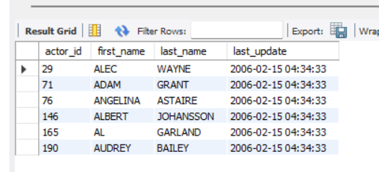

1. Create a view which displays the actor table in the descending order of their last name

create view actor_ordered_by_last_name as select * from actor order by last_name desc;

select * from actor_ordered_by_last_name;

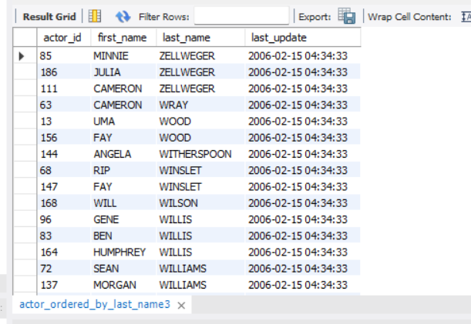

1. Delete the above created view

drop view actor_ordered_by_last_name;



# Language Table

1. Create a view to display language id, name and last update

create view lang as select * from language;

select * from lang;

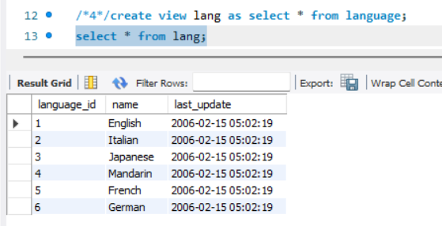

1. Insert following record with name and last update in the view, also verify whether it has been inserted in base table or not

(‘Hindi’, ‘2013-07-05 ‘12:23:05’)

/*5*/insert into lang(name,last_update) values ('HINDI','2013-07-05 12:23:05');

select * from lang;

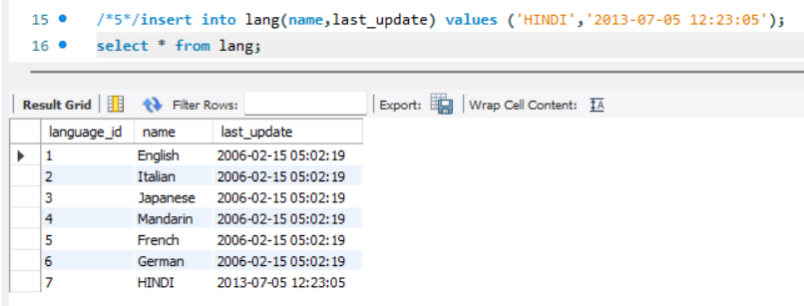

1. Update the language of the newly inserted record to ‘Spanish’ and verify whether it has been updated in the base table or not

/*6*/ UPDATE lang set name='SPANISH' WHERE name='HINDI';

SELECT * FROM lang WHERE name = 'SPANISH';

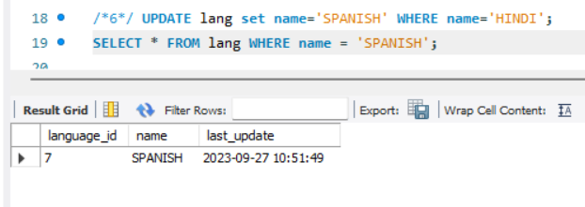

1. Delete the record of Spanish Language and verify whether it has been deleted from the base table or not

/*7*/delete from lang where name='SPANISH';

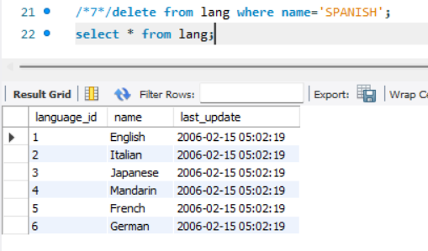

1. Create a view which stores language id, name and last update for those records which are last updated on ‘2006-02-15 05:02:19’ with check option

/*8*/CREATE VIEW lang_2 AS SELECT * FROM language where last_update='2006-02-15 05:02:19' with check option;

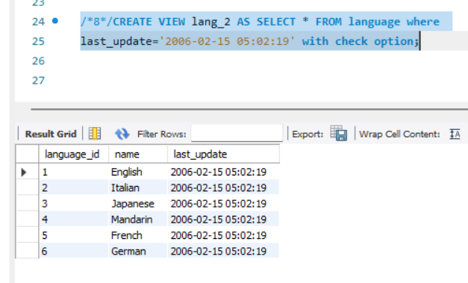

1. Insert a new record with language Hindi and last update as ‘2020-07-13 10:00:19’ and verify whether it has been inserted or not

/*9*/INSERT INTO lang_2(name,last_update) VALUES ('HINDI','2020- 07-13 10:00:19');

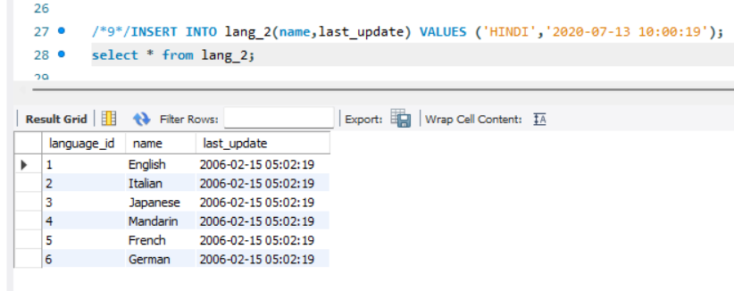

1. Insert a new record with language Hindi and last update as ‘2006-02-15

05:02:19’ and verify whether it has been inserted or not

/*10*/INSERT INTO lang_2(name,last_update) VALUES ('HINDI','2006- 02-15 05:02:19');

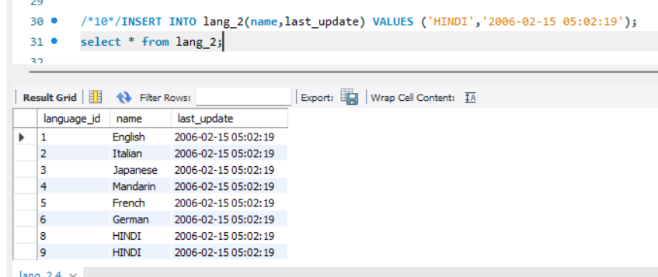

1. Update the newly inserted record with last update as ‘2020-07-13 10:00:19’ and verify whether it has been updated or not

/*11*/UPDATE lang_2 SET last_update='2020-07-13 10:00:19' WHERE name='HINDI';

